Ideation Phase
Brainstorm & Idea Prioritization Template
Date | 24 June 2025
Team ID | LTVIP2026TMIDS36755
Project Name | ToyCraft Tales: Tableau's vision into toy manufacturer data
Maximum Marks | 4 Marks
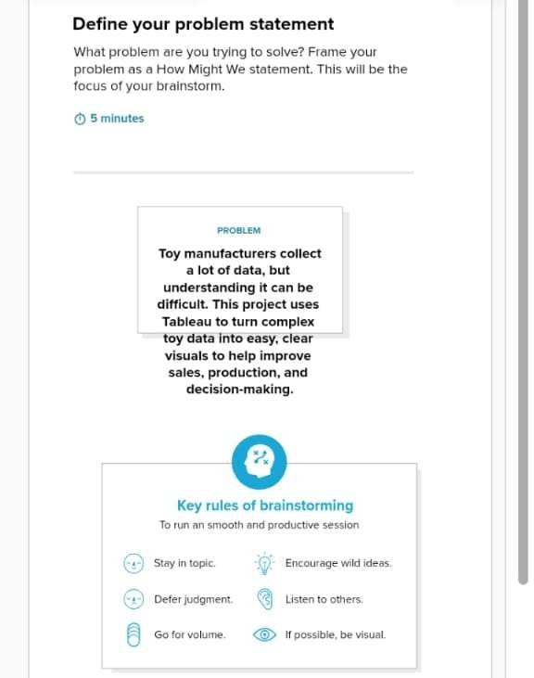
Brainstorm & Idea Prioritization Template:
Brainstorming provides a free and open environment that encourages everyone within a team to participate in the creative thinking process that leads to problem solving. Prioritizing volume over value, out-of-the-box ideas are welcome and built upon, and all participants are encouraged to collaborate, helping each other develop a rich amount of creative solutions.
Use this template in your own brainstorming sessions so your team can unleash their imagination and start shaping concepts even if you're not sitting in the same room.
Reference: https://www.mural.co/templates/brainstorm-and-idea-prioritization
Step-1: Team Gathering, Collaboration and Select the Problem Statement
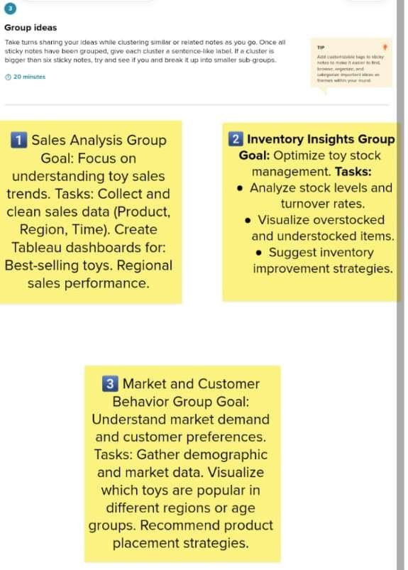
Step-2: Brainstorm, Idea Listing and Grouping
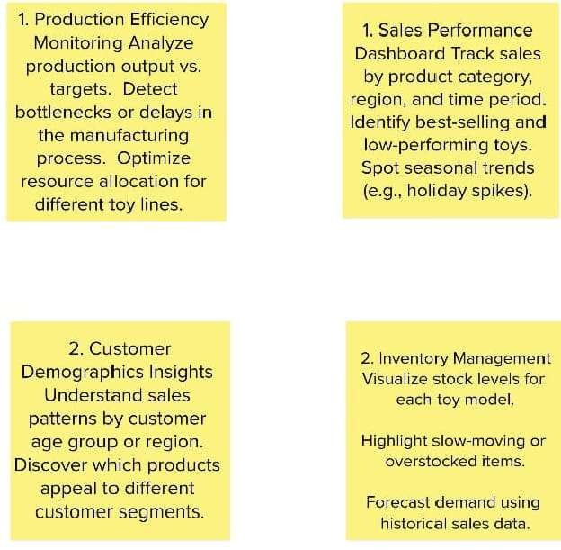
Step-3: Idea Prioritization
